To connect to posgresql database we should do follow.

Edit file pg_hba.conf, that placed here: \\m1-sim\c$\ProgramData\HP\RS\DATA\DATABASE\
We should change method of authorisation to “trust”. This method allow us connect to database via tcp/ip and without password.

host all all 127.0.0.1/32 trust
host all all 172.16.28.68/32 trust
host all all ::1/128 trust

To apply new settings we should restart this service.
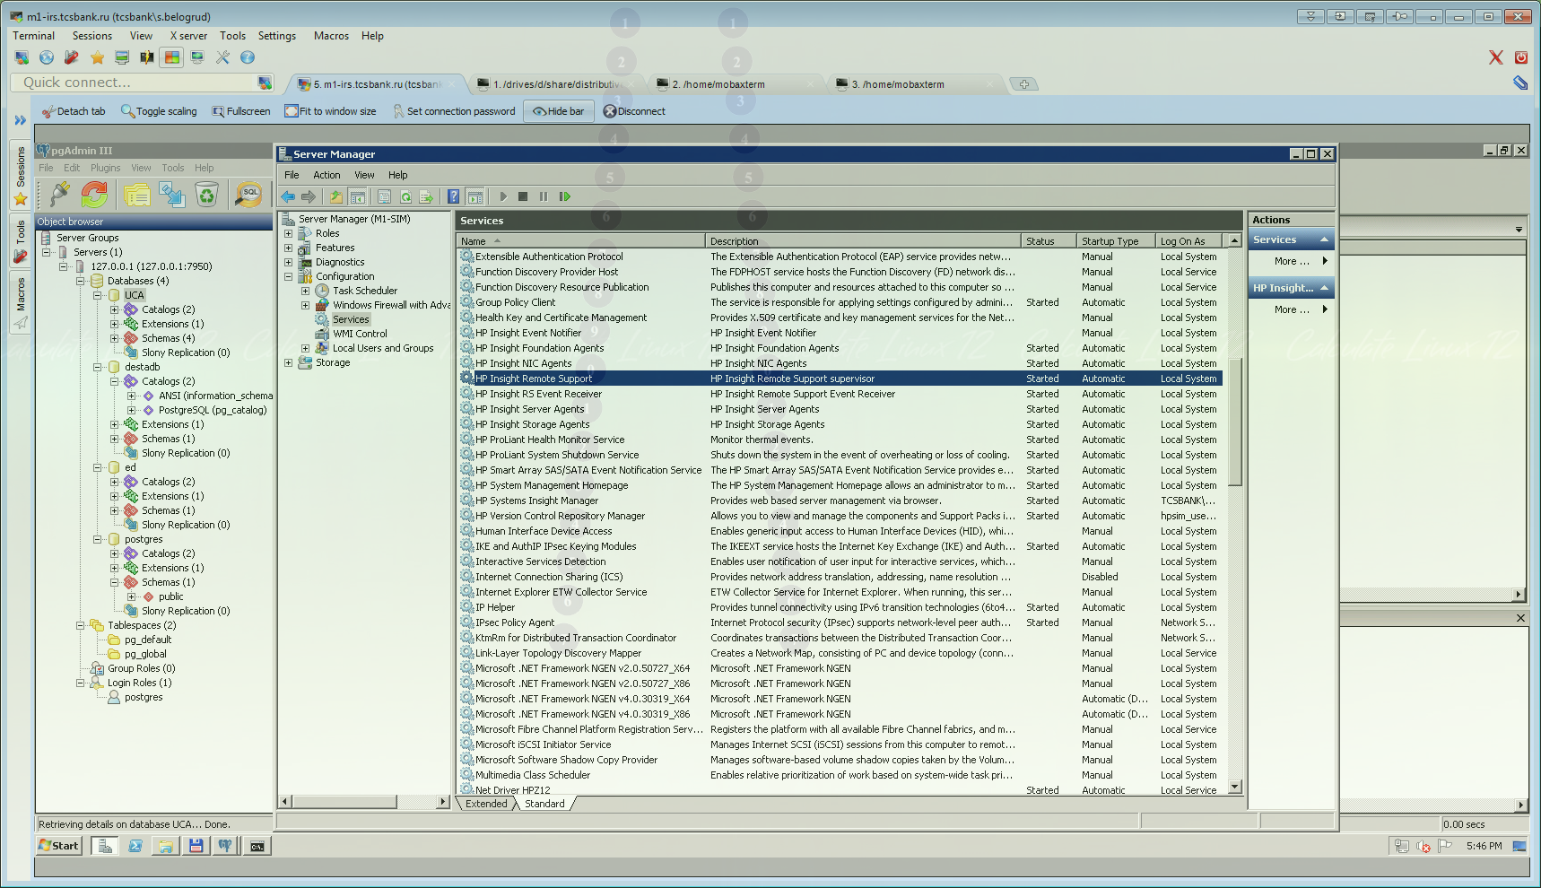

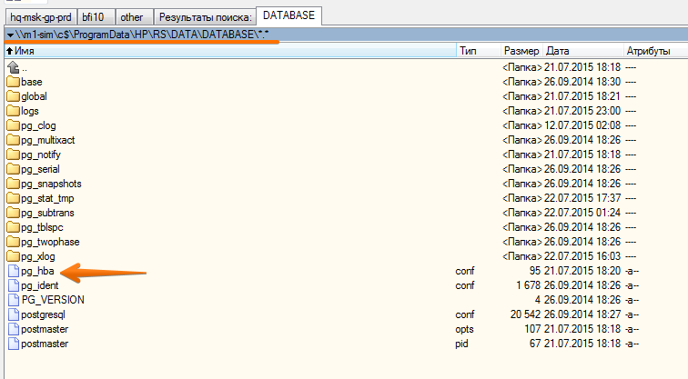

Next step we can grant access from our workstation to postgres.

Edit this file
\\m1-sim\c$\ProgramData\HP\RS\DATA\DATABASE\postgresql.conf
Add this line at bottom of this file.

# Add settings for extensions here

listen_addresses = '*'
port = 7950
log_line_prefix = '%m|%p|%d|'
logging_collector = on
log_directory = 'logs'
log_filename = 'postgresql-%Y-%m-%d_%H%M%S.log'
client_min_messages = log
log_min_messages = info
log_error_verbosity = verbose
log_min_error_statement = info
max_connections = 200

Then edit this file
\\m1-sim\c$\ProgramData\HP\RS\DATA\DATABASE\ pg_hba.conf
Add this line - here is ip-address of my workstation.
host all all 172.16.28.74/32 trust

Next step - is stop and start service:
“HP Insight Remote Support supervisor”.

And check results from local server:

c:\Program Files (x86)\HP\RS\postgresql_9_win32\bin>netstat -a | findstr 7950
TCP 0.0.0.0:7950 m1-sim:0 LISTENING
TCP 10.216.41.212:53550 qualys:57950 CLOSE_WAIT
TCP 127.0.0.1:7950 m1-sim:55547 ESTABLISHED
TCP 127.0.0.1:7950 m1-sim:55558 ESTABLISHED
TCP 127.0.0.1:7950 m1-sim:55562 ESTABLISHED
TCP 127.0.0.1:7950 m1-sim:55567 ESTABLISHED
TCP 127.0.0.1:7950 m1-sim:55588 ESTABLISHED
TCP 127.0.0.1:55547 m1-sim:7950 ESTABLISHED
TCP 127.0.0.1:55558 m1-sim:7950 ESTABLISHED
TCP 127.0.0.1:55562 m1-sim:7950 ESTABLISHED
TCP 127.0.0.1:55567 m1-sim:7950 ESTABLISHED
TCP 127.0.0.1:55588 m1-sim:7950 ESTABLISHED
TCP [::]:7950 m1-sim:0 LISTENING

c:\Program Files (x86)\HP\RS\postgresql_9_win32\bin>

Everything looks like working.
[support@centos00 .vim]$ telnet m1-irs.tcsbank.ru 7950
Trying 10.216.41.212...
Connected to m1-irs.tcsbank.ru.
Escape character is '^]'.
^]
telnet> quit
Connection closed.
[support@centos00 .vim]

Next step we can install the latest version of pgadmin and connect to posgres with it.

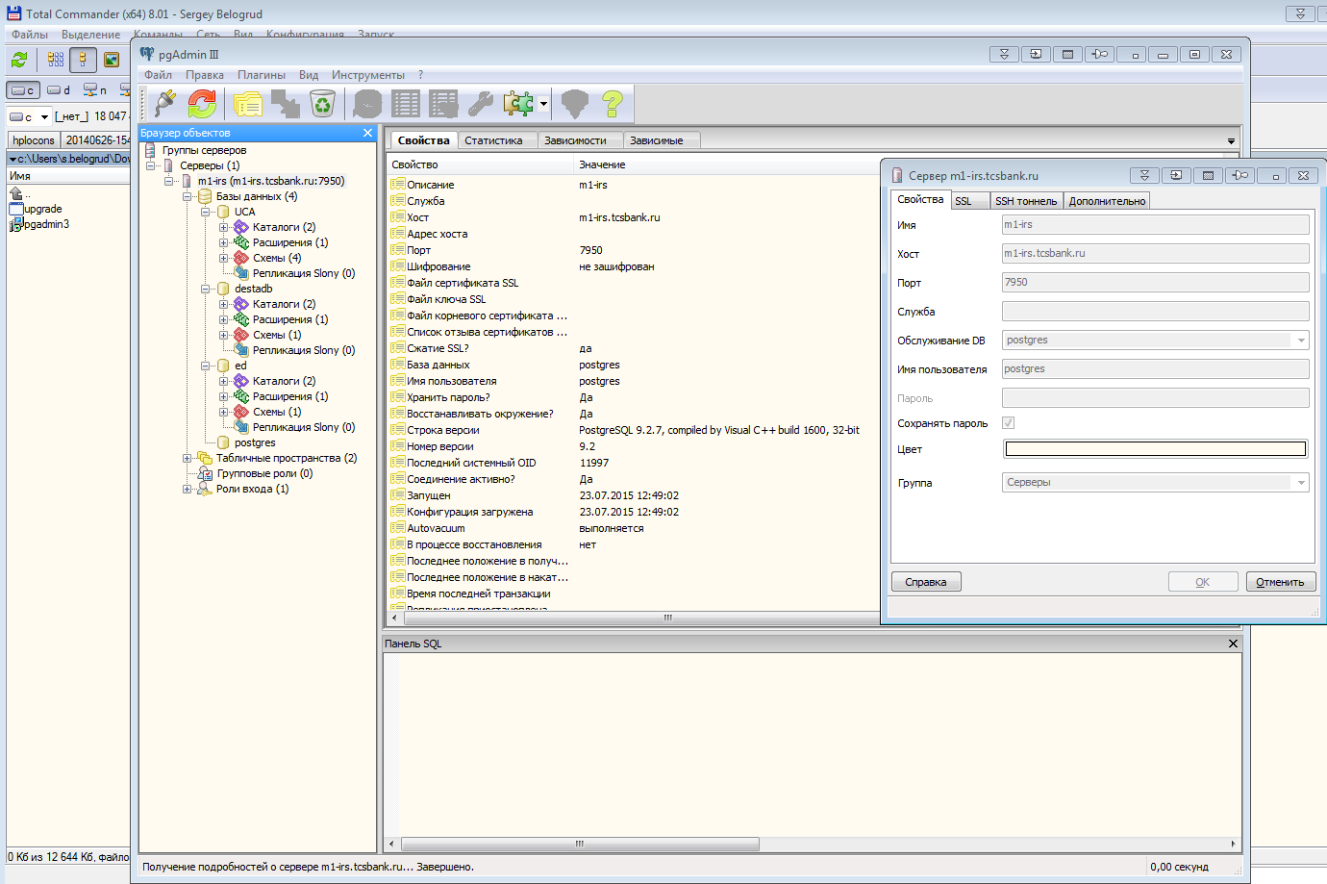

Here is example of quire from table prod.

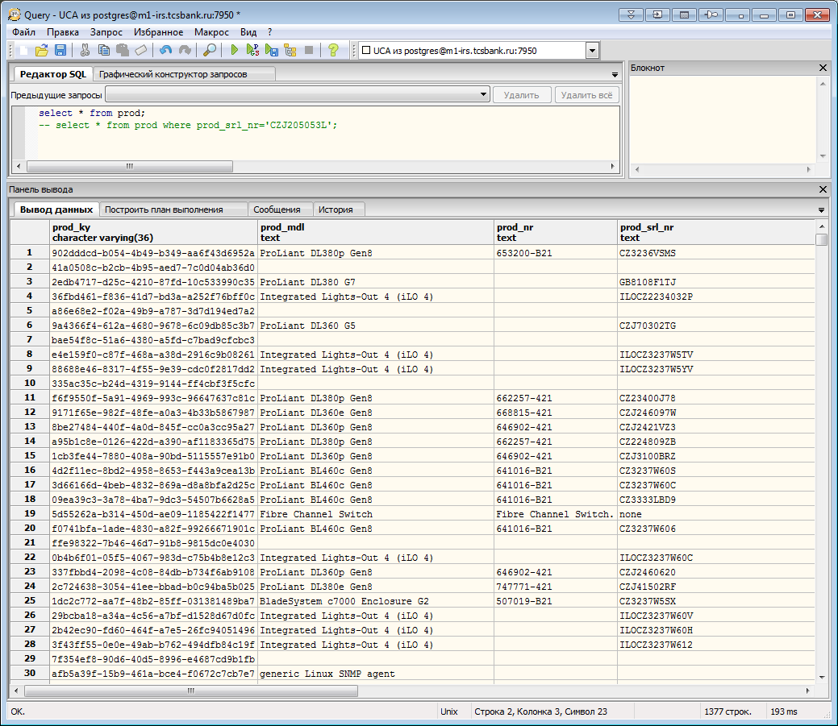

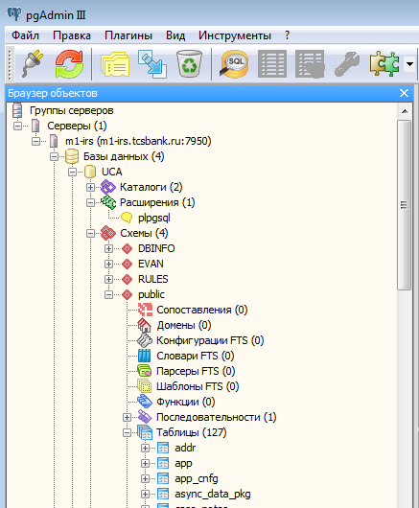

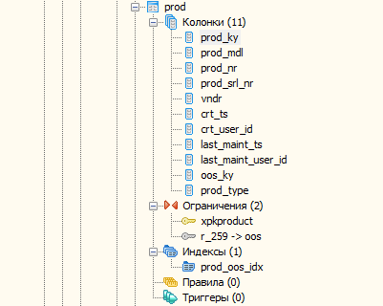

Interesting quires.

select * from prod ;
select * from cred where user_nm='tcsbank\s.belogrud';
-- select * from prod where prod_srl_nr='CZJ205053L';

select prod_srl_nr from prod where oos_ky in ( select oos_ky from cred where user_nm='tcsbank\s.belogrud' );

This method of connection we can use to do somthing from command line.
Here I have dumped one database.

c:\Program Files (x86)\HP\RS\postgresql_9_win32\bin>pg_dump.exe --data-only --in
serts -h 127.0.0.1 -p 7950 -U postgres UCA > 20150722-1735.uca.dump
pg_dump: NOTICE: there are circular foreign-key constraints among these table(s)
:
pg_dump: dvc_type
pg_dump: You might not be able to restore the dump without using --disable-trigg
ers or temporarily dropping the constraints.
pg_dump: Consider using a full dump instead of a --data-only dump to avoid this
problem.
pg_dump: NOTICE: there are circular foreign-key constraints among these table(s)
:
pg_dump: oos_type_l
pg_dump: You might not be able to restore the dump without using --disable-trigg
ers or temporarily dropping the constraints.
pg_dump: Consider using a full dump instead of a --data-only dump to avoid this
problem.
pg_dump: NOTICE: there are circular foreign-key constraints among these table(s)
:
pg_dump: sftwr_fmly_l
pg_dump: You might not be able to restore the dump without using --disable-trigg
ers or temporarily dropping the constraints.
pg_dump: Consider using a full dump instead of a --data-only dump to avoid this
problem.

c:\Program Files (x86)\HP\RS\postgresql_9_win32\bin>

Here is how it looks if we connect to postgresql from gpadmin.

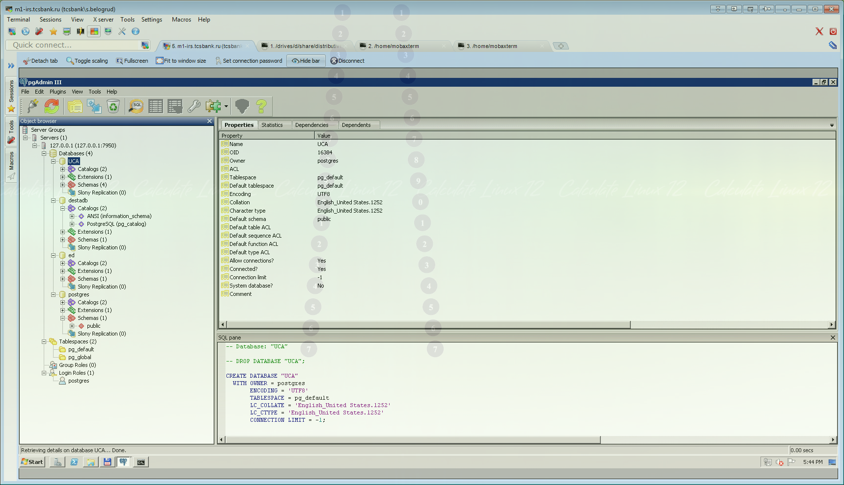

20150728
Here is final query to find all records where my account used to in IRS server database.

select prod_srl_nr from prod where oos_ky in ( select oos_ky from cred where user_nm='tcsbank\s.belogrud' );
-- select * from prod where prod_srl_nr='CZJ205053L';

